AI ASS 13.4
Name:G.Srinidhi
H.T.NO:2303A52285
Batch:43

Task1:
Prompt:
Refactor the Python code that uses a loop to double the values in a list. Suggest a more Pythonic approach using list comprehension while keeping the output the same.
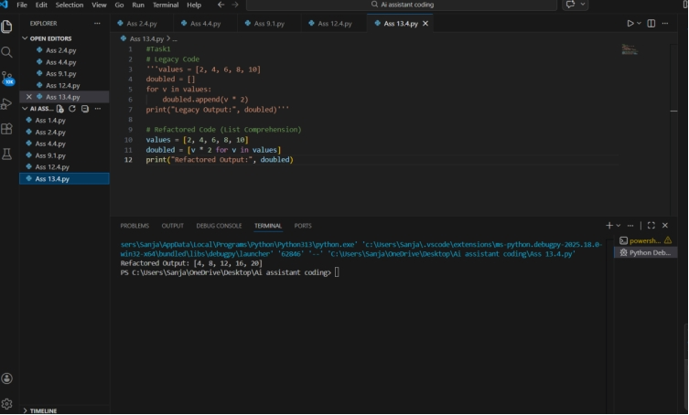
Observation:
The legacy code uses a loop to double the values in a list. After refactoring using list comprehension, the code becomes shorter, more readable, and efficient while producing the same output.

Task2
Prompt:
Improve the readability and efficiency of the Python code that builds a sentence using repeated string concatenation. Suggest a better Python method while keeping the output unchanged.
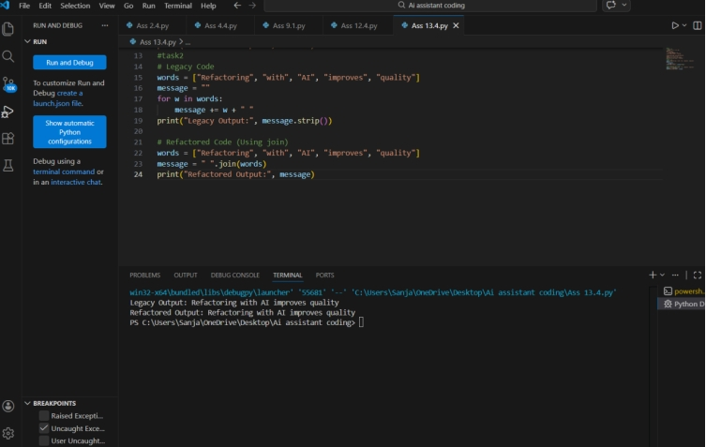
Observation:
The legacy code builds a sentence using repeated string concatenation, which is inefficient. Using the join() method improves readability and performance while maintaining the same result.

Task3
Prompt:
Refactor the Python code that manually checks dictionary keys. Suggest a safer way to access dictionary values using built-in Python methods while maintaining the same behavior for missing keys.
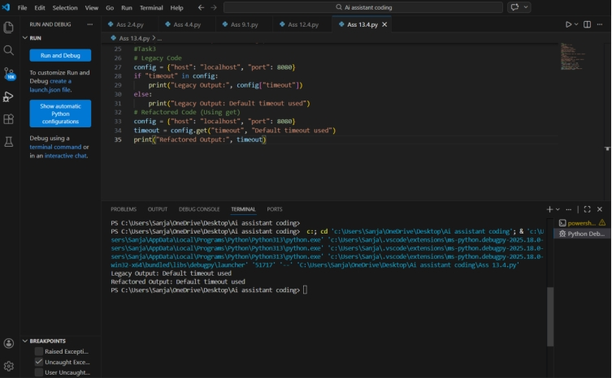

Observation:
The original code manually checks if a key exists in the dictionary. Using the get() method provides a safer and more concise way to access dictionary values without causing errors.

Task4
Prompt:
Refactor the Python code that uses multiple if–elif conditions to perform operations. Suggest a cleaner and scalable approach using mapping techniques such as dictionaries while preserving the functionality.
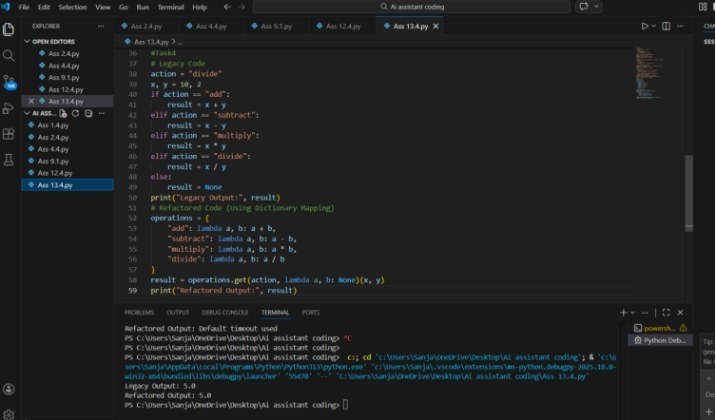

Observation:
The legacy code uses multiple if-elif conditions to perform operations. Refactoring with a dictionary mapping makes the code cleaner, easier to maintain, and more scalable.

Task5
Prompt:
Refactor the Python code that searches for an item in a list using a manual loop. Suggest a more concise and readable Python approach while keeping the output behavior the same.
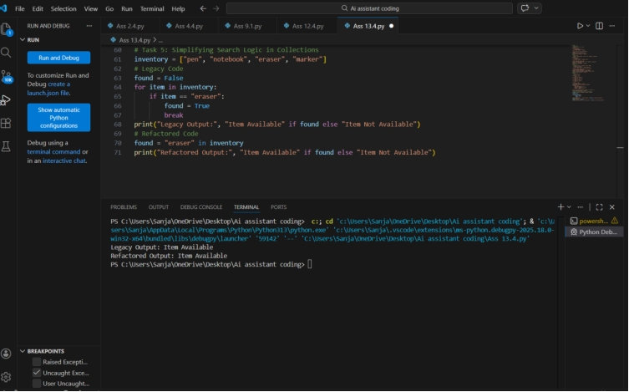

Observation:
The legacy code searches for an item in a list using a manual loop. Refactoring with Python’s built-in in operator simplifies the code and improves readability while keeping the same functionality.

